DEVELEOPING AN ONLINE HEALTH AND WELLNESS APP USING JAVA APPLETS

A CAPSTONE PROJECT

Submitted By

Sahithi .J

192211980

In Partial Fulfillment for the completion of the course

**CSA0912**

**Programming in Java for Accessing Database**

Sep 2024



SAVEETHA INSTITUTE OF MEDICAL AND TECHNICAL SCIENCES

CHENNAI - 602105

TAMIL NADU, INDIA



# BONAFIDE CERTIFICATE

This is to certify that the project report entitled “**Developing an online health and wellness app using java applets”** submitted by J. Sahithi to Saveetha School of Engineering, Saveetha Institute of Medical and Technical Sciences, Chennai, is a record of Bonafede work carried out by him/her under my guidance. The project fulfills the requirements per this institution's regulations and in my appraisal meets the required standards for submission.

Dr. K. Jayasakthi Velmurugan

**COURSE FACULTY**

*Department of Deep Learning.*

*Saveetha School of Engineering,*

*SIMATS, Chennai - 602105*

# ACKNOWLEDGEMENT

This project work would not have been possible without the contribution of many people. It gives me immense pleasure to express my profound gratitude to our Honorable Chancellor **Dr. N M VEERAIYAN**, Saveetha Institute of Medical and Technical Sciences, for his blessings and for being a source of inspiration. I sincerely thank our Director of Academics **Dr. DEEPAK NALLASWAMY,** SIMATS, for his visionary thoughts and support. I am indebted to extend my gratitude to our Director **Dr. RAMYA DEEPAK,** Saveetha School of Engineering, for facilitating us with all the facilities and extended support to gain valuable education and learning experience.

I register my special thanks to **Dr. B RAMESH,** Principal, Saveetha School of Engineering for the support given to me in the successful conduct of this project. I wish to express my sincere gratitude to my Course faculty **Dr. K. Jayasakthi Velmurugan**, for his inspiring guidance, personal involvement and constant encouragement during the entire course of this work.

I am grateful to Project Coordinators, Review Panel External and Internal Members and the entire faculty of the Department of Design, for their constructive criticisms and valuable suggestions which have been a rich source to improve the quality of this work.

## INDEX

BONAFIDE CERTIFICATE ........................................................................................................................... 1

ACKNOWLEDGEMENT ................................................................................................................................ 2

1. ABSTRACT ............................................................................................................................................... 4

2. INTRODUCTION ....................................................................................................................................... 4

1. ARCHITECTURE DIAGRAM ......................................................................................................................
2. FLOWCHART ........................................................................................................................................... 7
3. UML DIAGRAM ......................................................................................................................................... 8

6. CLASS DIAGRAM ..................................................................................................................................... 8

1. CODE IMPLEMENTATION .........................................................................................................................
   1. JAVA CODE .......................................................................................................................................
   2. BACK END
2. OUTPUT SCREENSHOT ....................................................................................................................... 10
3. CONCLUSION ........................................................................................................................................ 19
4. REFERENCES ...................................................................................................................................... 21

# 1. ABSTRACT

A health and wellness app is a digital platform designed to help individuals manage their overall well-being by tracking fitness, nutrition, and mental health. The app provides personalized plans based on users' goals, such as weight loss, muscle gain, or improving mental clarity. With integrated features like activity tracking, meal planning, and mindfulness exercises, the app offers a comprehensive solution to maintaining a healthy lifestyle. Users can log their daily activities, monitor progress, and receive tailored advice based on data inputs such as steps taken, calories consumed, and hours of sleep.

The app leverages modern technology like AI and data analytics to deliver customized recommendations that adapt to the user's changing health patterns. With wearable device integration, it can monitor vital statistics like heart rate, blood pressure, and activity levels in real-time, giving users insights into their physical well-being. Mental health features often include guided meditation, stress-relief techniques, and mood tracking, allowing users to keep tabs on their emotional well-being and take steps toward self-care.

Beyond tracking individual metrics, the health and wellness app fosters a sense of community by allowing users to connect with like-minded individuals and experts through forums, challenges, and live virtual classes. The app encourages users to set and achieve goals, whether for fitness, nutrition, or mental health, by providing motivational feedback and personalized coaching. In doing so, it empowers users to take charge of their health in an accessible and convenient manner. Mental health features often include guided meditation, stress-relief techniques, and mood tracking, allowing users to keep tabs on their emotional well-being and take steps toward self-care.

# 2. INTRODUCTION

A health and wellness app is a mobile or web-based platform designed to promote and enhance an individual's well-being by offering tools for tracking physical activity, managing nutrition, monitoring mental health, and setting personal goals. In today's fast-paced world, maintaining a healthy lifestyle can be challenging, and such apps provide users with convenient access to fitness resources, dietary recommendations, mindfulness practices, and health-related metrics all in one place. These apps are becoming increasingly popular as people look for ways to stay healthy, manage stress, and achieve a balanced lifestyle, often from the convenience of their smartphones.

One of the key features of health and wellness apps is personalized goal-setting, allowing users to tailor their experience to meet specific objectives such as weight loss, muscle gain, or stress reduction. By inputting individual data, such as age, gender, fitness level, and dietary preferences, the app generates customized plans that adapt to the user's lifestyle. Activity trackers, meal planners, and fitness routines provide actionable steps to meet these goals, while progress tracking helps users stay motivated.

Mental health is another critical component of these apps, offering guided meditations, breathing exercises, and mood trackers to support emotional well-being. Many apps incorporate features to reduce stress, manage anxiety, and improve focus, helping users achieve not just physical health but also mental clarity. By fostering a holistic approach to wellness, the app encourages users to pay attention to both their body and mind. This dual focus on physical and mental health makes wellness apps essential tools for self-care, especially as awareness grows about the importance of mental health in overall well-being.

Finally, health and wellness apps often create a sense of community by allowing users to connect with friends, fitness experts, and wellness coaches. Users can participate in challenges, attend live classes, and share their progress on social platforms, making the journey toward health more interactive and motivating. With continuous updates and the use of emerging technologies like artificial intelligence and data analytics, these apps are evolving to become smarter, more user-friendly, and capable of providing more accurate insights into individual health, making them indispensable companions in the pursuit of a healthier lifestyle.

# 3. ARCHITECTURE DIAGRAM

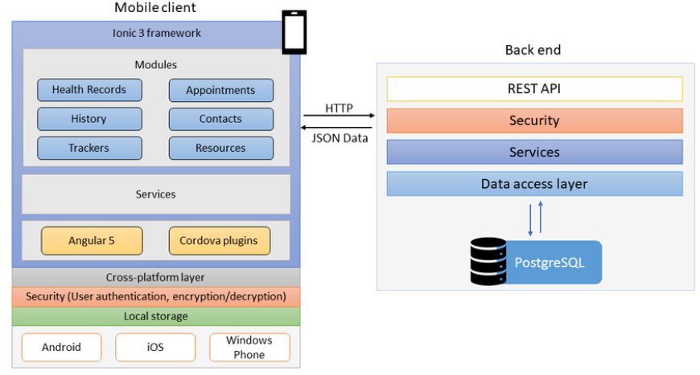

# 4. FLOWCHART

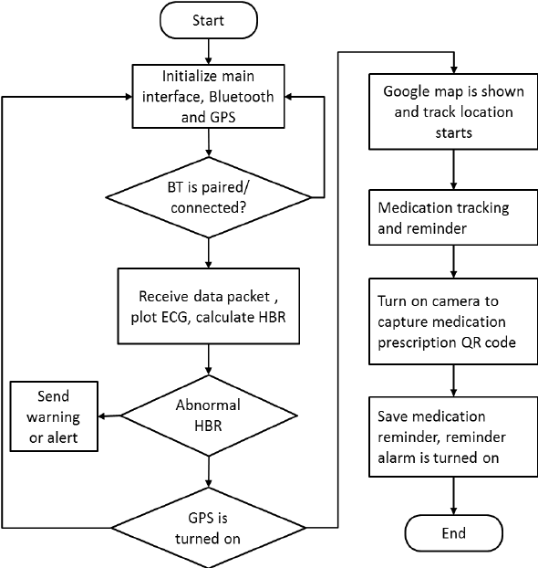

.

# 

# 5. UML DIAGRAM

**USE CASE DIAGRAM**

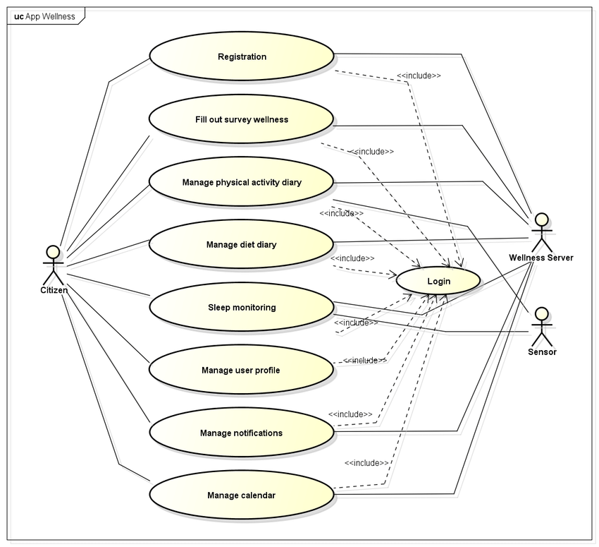

# CLASS DIAGRAM

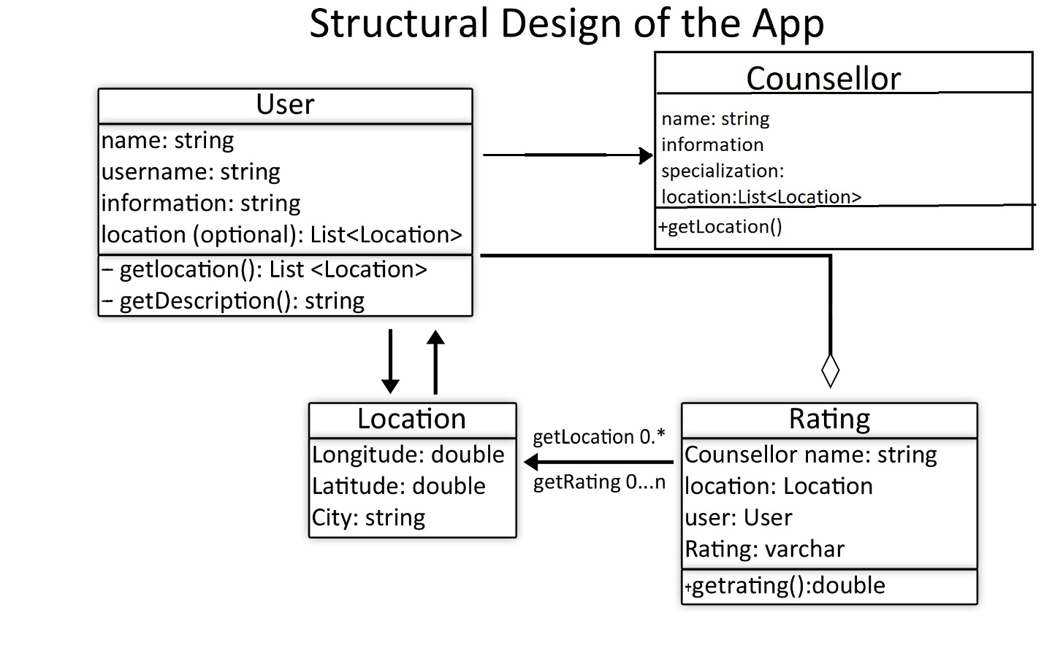Health Care Appointment System Class DiagramHealth Care Appointment System Class Diagram

Health Care Appointment System Class Diagram

Health Care Appointment System Class Diagram

## 7. CODE IMPLEMENTATION

### USER CLASS:-

import java.util.Scanner;

public class HealthWellnessApp {

public static void main(String[] args) {

Scanner scanner = new Scanner(System.in);

boolean exit = false;

while (!exit) {

System.out.println("Welcome to the Health and Wellness App!");

System.out.println("1. Log Health Data");

System.out.println("2. Calculate BMI");

System.out.println("3. Track Calories");

System.out.println("4. Exit");

System.out.print("Choose an option: ");

int option = scanner.nextInt();

switch (option) {

case 1:

logHealthData(scanner);

break;

case 2:

calculateBMI(scanner);

break;

case 3:

trackCalories(scanner);

break;

case 4:

exit = true;

System.out.println("Thank you for using the Health and Wellness App!");

break;

default:

System.out.println("Invalid option. Please choose again.");

}

}

scanner.close();

}

**// Function to log health data**

public static void logHealthData(Scanner scanner) {

System.out.print("Enter your name: ");

String name = scanner.next();

System.out.print("Enter your age: ");

int age = scanner.nextInt();

System.out.print("Enter your weight (kg): ");

double weight = scanner.nextDouble();

System.out.print("Enter your height (m): ");

double height = scanner.nextDouble();

System.out.println("Health Data Logged:");

System.out.println("Name: " + name);

System.out.println("Age: " + age);

System.out.println("Weight: " + weight + " kg");

System.out.println("Height: " + height + " m");

}

**MAIN CLASS:**

**// Function to calculate BMI**

public static void calculateBMI(Scanner scanner) {

System.out.print("Enter your weight (kg): ");

double weight = scanner.nextDouble();

System.out.print("Enter your height (m): ");

double height = scanner.nextDouble();

double bmi = weight / (height * height);

System.out.printf("Your BMI is: %.2f\n", bmi);

if (bmi < 18.5) {

System.out.println("You are underweight.");

} else if (bmi >= 18.5 && bmi < 24.9) {

System.out.println("You have a normal weight.");

} else if (bmi >= 25 && bmi < 29.9) {

System.out.println("You are overweight.");

} else {

System.out.println("You are obese.");

}

}

**// Function to track calories**

public static void trackCalories(Scanner scanner) {

System.out.print("Enter calories consumed today: ");

int calories = scanner.nextInt();

if (calories < 2000) {

System.out.println("You are below the recommended daily intake.");

} else if (calories >= 2000 && calories <= 2500) {

System.out.println("You are within the recommended daily intake.");

} else {

System.out.println("You have exceeded the recommended daily intake.");

}

}

}

**8. OUTPUT SCREENSHOT**

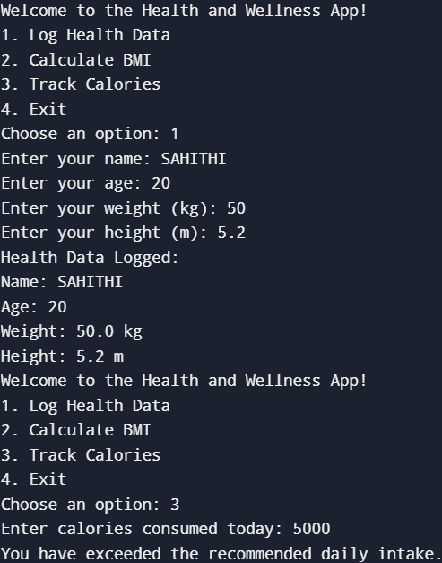

# 

# 9. CONCLUSION

In conclusion, A Health and Wellness app plays a crucial role in improving users' quality of life by promoting healthy habits and facilitating better lifestyle management. By allowing users to track their health data, such as weight, height, and calorie intake, the app enables individuals to gain valuable insights into their overall well-being. The inclusion of features like BMI calculation helps users assess their health status and make informed decisions about fitness goals, weight management, and dietary adjustments.

Moreover, the app offers personalized health monitoring that empowers users to stay consistent in their wellness journeys. Tracking daily calories and providing feedback based on individual goals ensures that users remain mindful of their eating habits, contributing to healthier long-term outcomes. With regular use, the app becomes a tool for self-awareness, guiding users to adopt a more balanced lifestyle, while offering them control over their fitness and nutrition choices.

Overall, a well-designed Health and Wellness app can have a profound impact on promoting positive behavioral changes. By combining user-friendly interfaces with accurate health data analysis, the app encourages users to actively manage their well-being and set achievable health targets. As the app evolves, it can incorporate more advanced features like mental health tracking, exercise plans, and goal setting, making it an essential part of a holistic approach to maintaining a healthy lifestyle.

# 10. REFERENCES

* **Boulos, M. N. K., Brewer, A. C., Karimkhani, C., Buller, D. B., & Dellavalle, R. P. (2014)**. "Mobile Medical and Health Apps: State of the Art, Concerns, Regulatory Control and Certification." Online Journal of Public Health Informatics.
* **Krebs, P., & Duncan, D. T. (2015)**. "Health App Use Among US Mobile Phone Owners: A National Survey." JMIR mHealth and uHealth.
* **Payton,F.C.,Pare,G., Le Rouge, C., &Reddy, M. (2011).** "Health Information Technology for Improving Quality of Care in Chronic Disease." Health Care Management Review.
* **Boogerd, E. A., Arts, T., Engelen, L. J., & van de Belt, T. H. (2015).** "What Is eHealth: Time for An Update?" JMIR Research Protocols.
* **Lupton, D. (2014).** "Health Promotion in The Digital Era: A Critical Commentary." Health Promotion International.
* **Pagoto, S., Schneider, K., Jojic, M., Debiasse, M., & Mann, D. (2013).** "Evidence-Based Strategies in Weight-Loss Mobile Apps." American Journal of Preventive Medicine.
* **Zhao, J., Freeman, B., & Li, M. (2016).** "Can Mobile Phone Apps Influence People’s Health Behavior Change? An Evidence Review." Journal of Medical Internet Research.
* **Toscos, T., Carpenter, M., Flanagan, M., Kunjan, K., & Montague, E. (2016).** "Identifying Successful Practices in Health and Wellness Mobile Apps." Proceedings of the Human Factors and Ergonomics Society Annual Meeting.
* **Gimpel, H., Nißen, M., & Görlitz, R. (2013).** "Quantifying the Quantified Self: A Study on the Motivations of Patients to Track Their Own Health." Information Systems and e-Business Management.
* **ischer, H. H., Moore, S. L., Ginosar, D., Davidson, A. J., Rice-Peterson, C., Durfee, M. J., & Sussman, J. O. (2012).** "mHealth App Use by Community Health Workers in Rural Guatemala." Global Health Science and Practice.
* **Thompson, D., Baranowski, T., Buday, R., Baranowski, J., Thompson, V., Jago, R., & Griffith, M. J. (2010).** "Serious Video Games for Health: How Behavioral Science Guided the Development of a Serious Video Game." Simulation & Gaming.